**What is Amazon S3?**

Amazon S3 (Simple Storage Service) is a cloud storage service.

**Storage for the Internet**: Amazon S3 allows you to store and retrieve any amount of data at any time, from anywhere on the web.

**Scalable**: You can store as much or as little data as you need. It grows with your needs.

**Durable and Reliable**: Data stored in S3 is designed to provide 99.999999999% durability, meaning your data is very safe from loss.

**Buckets**: Think of a bucket as a container for your data. When you store something in S3, you first create a bucket.

**Objects**: An object is the individual piece of data you store in S3. This can be any kind of file: a document, image, video, backup, etc.

**Keys**: Each object in S3 is identified by a unique key within a bucket. It’s like a filename in a folder on your computer.

**Regions**: Data in S3 is stored in specific geographical regions. You choose a region to keep your data close to where it will be used.

**How to Use S3**

**Create a Bucket**: Use the AWS Management Console, CLI, or SDK to create a bucket.

**Upload Objects**: Once you have a bucket, you can upload objects (files) to it.

**Access Objects**: You can retrieve or download your objects whenever you need them.

**Features**

**Versioning**: Keep multiple versions of an object to protect against accidental deletions and overwrites.

**Access Control**: Control who can access your data using permissions and bucket policies.

**Lifecycle Policies:** Automatically move data to cheaper storage classes or delete it after a certain period.

**Use Cases**

**Backup and Restore**: Use S3 to back up important data and restore it when needed.

**Data Archiving**: Store infrequently accessed data cost-effectively.

**Content Storage and Delivery**: Store media files and serve them to users via the web.

**Example**

Imagine you run a photo-sharing website:

**Bucket**: Create a bucket called my-photo-site.

**Objects**: Upload user photos to this bucket, each photo being an object.

**Keys**: Each photo has a unique key, like user1/photo1.jpg.

**Object lock:**

>>> Object lock helps to prevent accidental deletion or modification of objects within an S3 bucket for a specified retention period.

>>> It provides an additional layer of protection for critical data that needs to be preserved for compliance or business reasons.

**Static web hosting:**

Static web hosting in Amazon S3 (Simple Storage Service) refers to the use of S3 to host a static website. A static website consists of web pages that include static content such as HTML, CSS, JavaScript, images, and other files that don't require server-side processing.

Hit the static web hosting link in server it will display the content what we have kept in **index.html** file.

**Example**: Index.html, error.html

**Life cycle management**:

Amazon S3 (Simple Storage Service) life cycle management involves a set of policies that automate the management of objects during their lifecycle. These policies enable you to define actions for Amazon S3 objects to reduce storage costs and manage data retention efficiently.

Here's a detailed explanation with examples:

**Key Components of S3 Life Cycle Management**

**Lifecycle Policies**: Rules that define the actions to be performed on objects at a certain point in their lifecycle.

**Transitions**: Moving objects between different storage classes (e.g., from Standard to Infrequent Access, or Glacier).

**Expiration**: Permanently deleting objects after a specified period.

**Prefix**: Lifecycle policies can be applied to objects with a certain prefix (i.e., objects with a common path).

**Common Storage Classes in S3**

**S3 Standard**: Used for frequently accessed data.

**S3 Intelligent-Tiering**: Optimizes costs by automatically moving data to the most cost-effective access tier.

**S3 Standard-IA (Infrequent Access)**: For data accessed less frequently, but requires rapid access when needed.

**S3 One Zone-IA**: Similar to Standard-IA but stored in a single availability zone.

**S3 Glacier**: Low-cost storage designed for archival, where retrieval times can be in minutes to hours.

**S3 Glacier Deep Archive**: The lowest-cost storage, for data that is rarely accessed and requires long retrieval times.

|  |  |  |  |  |
| --- | --- | --- | --- | --- |
| **Storage Class** | **Use Case** | **Availability** | **Durability** | **Cost** |
| **S3 Standard** | Frequently accessed data | 99.99% | 99.999999999% (11 nines) | Highest |
| **S3 Intelligent-Tiering** | Unknown/changing access patterns | 99.9% (frequent) | 99.999999999% (11 nines) | Moderate |
|  |  | 99% (infrequent) |  |  |
| **S3 Standard-IA** | Infrequently accessed, quickly needed | 99.90% | 99.999999999% (11 nines) | Lower than Standard |
| **S3 One Zone-IA** | Infrequently accessed, recreatable data | 99.50% | 99.999999999% (11 nines) | Lower than Standard-IA |
| **S3 Glacier** | Long-term archive, retrieval in hours | Not specified | 99.999999999% (11 nines) | Very low |
| **S3 Glacier Deep Archive** | Long-term archive, retrieval in days | Not specified | 99.999999999% (11 nines) | Lowest |
| **S3 Reduced Redundancy** | Non-critical, easily reproducible data | 99.99% | 99.99% (4 nines) | Lower than S3 Standard |

**Example Scenarios**

1. Transitioning Objects to Lower-Cost Storage Classes

Suppose you have log files that are frequently accessed for the first 30 days but rarely after that. You can set up a lifecycle policy to move these files to a cheaper storage class after 30 days.

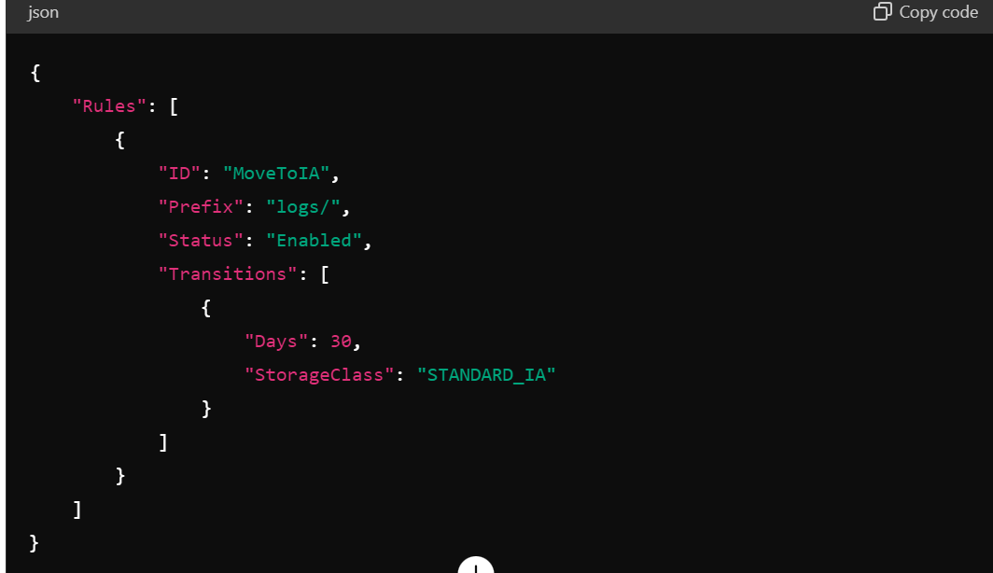

**Replication**:

Replication in AWS S3 (Amazon Simple Storage Service) is a feature that allows you to automatically and asynchronously copy objects across different S3 buckets, which can be within the same AWS region or across different regions. This functionality is known as Cross-Region Replication (CRR) or Same-Region Replication (SRR).

**Key Features of S3 Replication**

**Cross-Region Replication (CRR):** Replicates data across different AWS regions. This enhances disaster recovery and ensures low-latency data access for users in different geographic locations.

**Same-Region Replication (SRR)**: Replicates data within the same AWS region. This can be used to meet compliance and data sovereignty requirements or to create separate copies for data processing and analytics.

**Benefits of S3 Replication**

**Data Durability and Availability**: Replication helps ensure data durability and availability by creating additional copies of your objects in different locations.

**Compliance**: Helps meet compliance requirements by storing copies of data in multiple regions or locations.

**Disaster Recovery**: Provides a reliable disaster recovery solution by maintaining copies of data in geographically separated locations.

**Low-Latency Access**: Improves performance by storing copies of data closer to your users.

**Question**: What is AWS S3 and what are its key features?

**Answer:**

AWS S3 (Simple Storage Service) is a scalable object storage service designed for storing and retrieving any amount of data from anywhere on the web.

Key features include high availability, durability, scalability, security, and a simple web services interface for easy access to data.

**Question**: Can you explain the different storage classes in AWS S3 and when you would use each one?

**Answer**:

AWS S3 offers several storage classes, including Standard, Intelligent-Tiering, Infrequent Access (IA), and Glacier.

Standard is suitable for frequently accessed data, Intelligent-Tiering automatically moves objects between two access tiers based on access patterns, IA is for infrequently accessed data, and Glacier is for long-term archival.

**Question**: How do you control access to objects stored in AWS S3?

**Answer**:

Access to S3 objects can be controlled through bucket policies, IAM policies, and Access Control Lists (ACLs).

Bucket policies are applied at the bucket level, while IAM policies are applied to users or groups. ACLs can be applied at the object level.

**Question**: What are the different encryption options available for data stored in AWS S3?

**Answer**:

Encryption options include server-side encryption with Amazon S3 managed keys (SSE-S3), AWS Key Management Service (KMS) managed keys (SSE-KMS), and customer-provided keys (SSE-C).

**Question**: How do you optimize performance when accessing data in AWS S3?

**Answer**: Performance can be optimized by enabling multi-part uploads for large files, using AWS CloudFront for content delivery, and choosing the appropriate storage class based on access patterns.

**Question**: What is S3 Lifecycle Management and how can it be used to manage data?

Answer:

S3 Lifecycle Management allows automating the migration of objects between storage classes and deletion of objects based on predefined rules.

For example, you can use it to transition objects to cheaper storage classes after a certain period or delete objects after a specified expiration date.

**Question**: How does AWS S3 integrate with other AWS services?

**Answer**:

S3 integrates with various AWS services such as EC2, Lambda, Redshift, and CloudFront.

For example, you can store static website content in S3 and use CloudFront as a content delivery network to distribute the content globally.

**Question**: What is S3 Transfer Acceleration and when would you use it?

**Answer**:

S3 Transfer Acceleration speeds up file transfers to and from S3 by utilizing Amazon CloudFront’s globally distributed edge locations.

It is useful when transferring data over long distances or across networks with high latency.

**Question**: How is pricing calculated for AWS S3?

**Answer**:

S3 pricing is based on storage, requests, and data transfer. There are different pricing tiers for different storage classes and regions.

**Question**: How would you troubleshoot issues with accessing objects in AWS S3?

**Answer**:

Troubleshooting S3 issues involves checking permissions, ensuring the correct region is specified, and monitoring CloudWatch metrics for anomalies. You can also enable S3 access logs to track requests and identify errors.

**Basic Questions**

**What is Amazon S3?**

**Answer**: Amazon S3 (Simple Storage Service) is an object storage service that offers industry-leading scalability, data availability, security, and performance. Customers of all sizes and industries can use it to store and protect any amount of data for a range of use cases, such as websites, mobile applications, backup and restore, archive, enterprise applications, IoT devices, and big data analytics.

**How does S3 store data?**

**Answer**: S3 stores data as objects within buckets. An object consists of a file and optionally any metadata that describes that file. Buckets are containers for objects.

**What are the storage classes in S3?**

**Answer**: S3 offers several storage classes designed for different use cases, including:

S3 Standard

S3 Intelligent-Tiering

S3 Standard-IA (Infrequent Access)

S3 One Zone-IA

S3 Glacier

S3 Glacier Deep Archive

**Explain the concept of an S3 bucket.**

**Answer**: An S3 bucket is a container for storing objects in S3. Every object is contained in a bucket. Each bucket can be configured with its own policies, logging, and configurations such as versioning and encryption.

**What is the maximum size of an object that can be stored in S3?**

**Answer**: The maximum size of a single object that can be uploaded in a single PUT operation is 5 GB. For larger objects, you can use the Multipart Upload API to upload objects up to 5 TB.

**Intermediate Questions**

**What are S3 Bucket Policies and ACLs (Access Control Lists)?**

**Answer**: Bucket Policies and ACLs are used to manage permissions for S3 buckets and objects. Bucket Policies are JSON-based access policy language statements that define what actions are allowed or denied on the bucket and its objects. ACLs are a legacy access control mechanism that defines grants to individual AWS accounts or predefined groups.

**How does versioning work in S3?**

**Answer**: Versioning in S3 is a means of keeping multiple versions of an object in the same bucket. Once you enable versioning for a bucket, S3 will keep all versions of an object, including all writes and even if you delete an object. You can then retrieve or restore a previous version of an object.

**Explain S3 Lifecycle Rules.**

**Answer**: Lifecycle Rules in S3 allow you to define actions to automatically transition objects to another storage class or expire/delete them after a specified period. This helps in managing the lifecycle of objects and optimizing storage costs.

**What is the purpose of the S3 Transfer Acceleration feature?**

**Answer**: S3 Transfer Acceleration enables fast, easy, and secure transfers of files over long distances between your client and your S3 bucket. It takes advantage of Amazon CloudFront's globally distributed edge locations to accelerate uploads.

**How can you secure data in S3?**

**Answer**: You can secure data in S3 by:

Using bucket policies and ACLs to control access.

Enabling SSL/TLS for data in transit.

Using S3 encryption for data at rest (Server-Side Encryption with S3-Managed Keys (SSE-S3), Server-Side Encryption with KMS-Managed Keys (SSE-KMS), or Client-Side Encryption).

Enabling versioning to recover from accidental deletions or overwrites.

Enabling MFA (Multi-Factor Authentication) Delete to protect against accidental deletions.

**Advanced Questions**

**What is S3 Event Notification and how does it work?**

**Answer**: S3 Event Notifications enable you to receive notifications when certain events happen in your bucket. You can configure S3 to send notifications to AWS Lambda, SQS (Simple Queue Service), or SNS (Simple Notification Service) when specific events, such as object creation, deletion, or restoration, occur.

**Describe the S3 Consistency Model.**

**Answer**: S3 provides strong read-after-write consistency for PUTS of new objects and eventual consistency for overwrite PUTS and DELETES in all regions. This means that once a new object is written to S3, it can be immediately read, but if an object is updated or deleted, there might be some propagation delay before the change is fully reflected.

**How can you optimize performance for your S3 requests?**

**Answer**: Performance optimization in S3 can be achieved by:

Using appropriate storage classes for your access patterns.

Enabling S3 Transfer Acceleration for faster uploads.

Using Multi-part upload for large files.

Leveraging CloudFront for caching frequently accessed objects.

Distributing your read requests across multiple prefixes to avoid request throttling.

**What is the difference between S3 Glacier and S3 Glacier Deep Archive?**

**Answer**: S3 Glacier is designed for long-term storage of data that is rarely accessed but requires rapid retrieval (typically within minutes to hours). S3 Glacier Deep Archive is designed for data that is accessed less frequently (once or twice a year) and can tolerate longer retrieval times (up to 12 hours). It offers lower storage costs compared to S3 Glacier.

**Explain the concept of S3 Object Lock.**

**Answer**: S3 Object Lock allows you to store objects using a write-once-read-many (WORM) model. It can help prevent objects from being deleted or overwritten for a specified period or indefinitely. Object Lock is useful for meeting regulatory requirements that require immutable data storage.